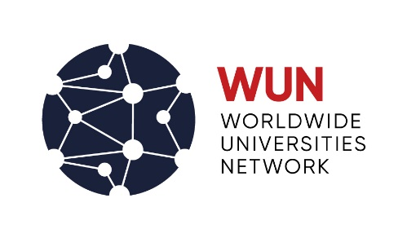

RESEARCH MOBILITY Programme

APPLICATION FORM: Staff

Please complete and return this application, including supporting documents, as one complete PDF document, to global-partnerships@york.ac.uk by 5pm on Monday 24 October 2022. Applications received after this date will not be accepted.
Home University: |  |  |  |  | Host University:
Date of application: |  |  |  |  | Staff number:

Are you on a fixed term contract? Yes/No

If yes, what is your contract end date? :
First name: |  |  |  | Last name: |  |  |  |  | Title
Department: |  |  |  | Position:
Applicant’s Address: |  |  |  |  |  |  |  |  | Telephone No:
Proposed host institution:
Host Academic:
Host Academic address:

Telephone No:
Email:

Proposed project title:
Proposed start date: |  |  |  |  |  |  | Proposed end date:
Please provide details of any research and academic links which already exist between your department and the department in the WUN partner institution.

Details of funding applied for (please attach an extra sheet if necessary):
Funding guidelines:
- Travel and accommodation: economy airfare, internal travel costs to host institution, and visa costs
- Research Expenses
- Subsistence

Item | Detail |  |  |  |  |  |  | Total
Travel expenses
Subsistence costs
Accommodation
Research expenses

Total claimed
Details of other funding secured
In no more than 1,000 words please provide information on the following in an attached, signed document
(a) summary of the research you intend to undertake, detailing proposed interactions with the WUN partner institution
(b) the anticipated benefits of the award, both for yourself and for the universities involved
(c) any exceptional expertise or facilities available to you through this visit
(d) how you and your department propose to sustain research relationships built through your visit
(e) how your application contributes to the University’s mission and strategy and/or one of the University’s seven research themes.
We require a supporting statement from the host academic to be attached to this application
Name
Email address
We require a supporting statement from your Head of Department to be attached to this application

This statement should explain the benefits to you and your department, and should indicate how the research relationships built will be sustained after the visit.

Name
Email address

Statement from applicant
I wish to apply for a Worldwide Universities Network Staff RMP Award. If successful, I undertake to observe the Award Regulations and to provide a detailed final report within 1 month of the completion of the project.
I agree that the University and the Worldwide Universities Network may hold and process personal information in connection with this RMP and may use my name and the information relating to this proposed research visit for publicity purposes.

Signed: |  |  |  |  |  | Date:

